**Computer Networks Lab#4**



**Session: 2021**

**Submitted by:**

**Wali Muhammad 2021-SE-39**

**Submitted to:**

**Sir Umer Rasheed**

Department of Computer Science

University of Engineering and Technology, New Campus, Lahore

1. Select the first UDP segment in your trace. What is the packet number of this segment in the trace file? What type of application-layer payload or protocol message is being carried in this UDP segment? Look at the details of this packet in Wireshark. How many fields there are in the UDP header? (You shouldn’t look in the textbook! Answer these questions directly from what you observe in the packet trace.) What are the names of these fields?

Packet Number: 1458  
Protocol message: The UDP segment is carrying a "Domain Name System (DNS)" protocol message. This is evident from the "Domain Name System (query)" section in the packet details.

The UDP header contains 4 fields: **source port, destination port, length, and checksum**.  
  
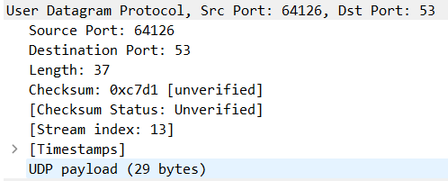

1. By consulting the displayed information in Wireshark’s packet content field for this packet (or by consulting the textbook), what is the length (in bytes) of each of the UDP header fields?

Each UDP header field have a length of 16 bits which is equal to 2 bytes long.

1. The value in the Length field is the length of what? (You can consult the text for this answer). Verify your claim with your captured UDP packet.

The entire UDP datagram is 37 bytes long, encompassing both the UDP header (8 bytes) and the UDP payload (29 bytes). As shown in above screenshot.

1. What is the maximum number of bytes that can be included in a UDP payload? (Hint: the answer to this question can be determined by your answer to 2. above)

The Length field in the UDP header is 16 bits, which means it can represent values from 0 to 65,535 (2^16 - 1). This field includes both the UDP header itself (8 bytes) and the UDP payload.  
So 65,535 – 8 = 65,527 bytes.

1. What is the largest possible source port number? (Hint: see the hint in 4.)  
     
     
   The largest possible source port number is 216 – 1 = 65535
2. What is the protocol number for UDP? Give your answer in decimal notation. To answer this question, you’ll need to look into the Protocol field of the IP datagram containing this UDP segment (see Figure 4.13 in the text, and the discussion of IP header fields).   
     
   Protocol number for UDP: 17  
   
3. Examine the pair of UDP packets in which your host sends the first UDP packet and the second UDP packet is a reply to this first UDP packet. (Hint: for a second packet to be sent in response to a first packet, the sender of the first packet should be the destination of the second packet). What is the packet number of the first of these two UDP segments in the trace file? What is the packet number of the second of these two UDP segments in the trace file? Describe the relationship between the port numbers in the two packets.   
     
   The source port of the UDP packet sent by the host is the same as the destination port of the reply packet, and conversely the destination port of the UDP packet sent by the host is the same as the source port of the reply packet.

Source Port and Destination Port of Sent  
  
  
  
Source Port and Destination Port of Replay  
  
